Ideation phase

# Brainstorm and idea prioritization

|  |  |
| --- | --- |
| Date | 30 April 2023 |
| Team ID | NM2023TMID21570 |
| Project Name | Empowering the Future: A Literacy Rate Analysis for a Be er Tomorrow. |
| Maximum Marks | 2 Marks |

Brainstorm, Idea Listing and Grouping:

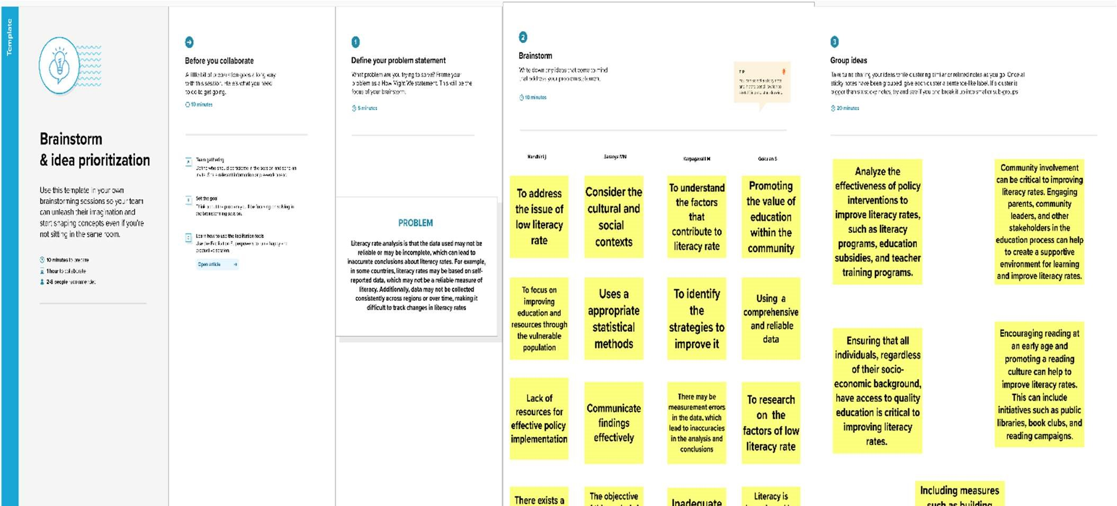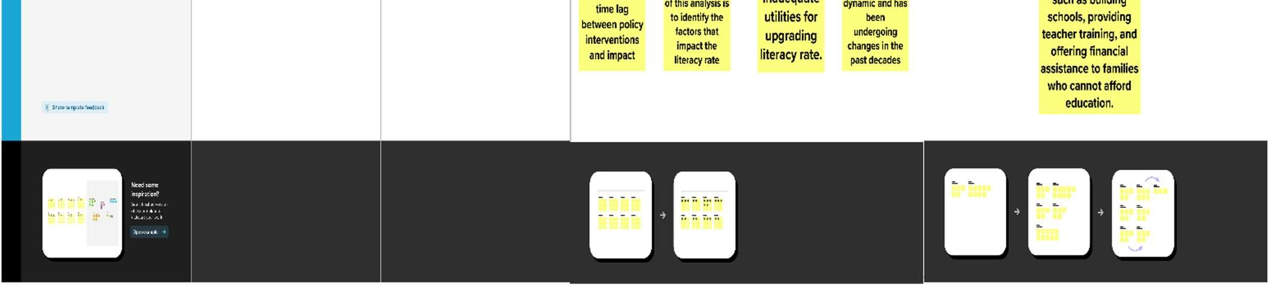

Idea prioritization:

